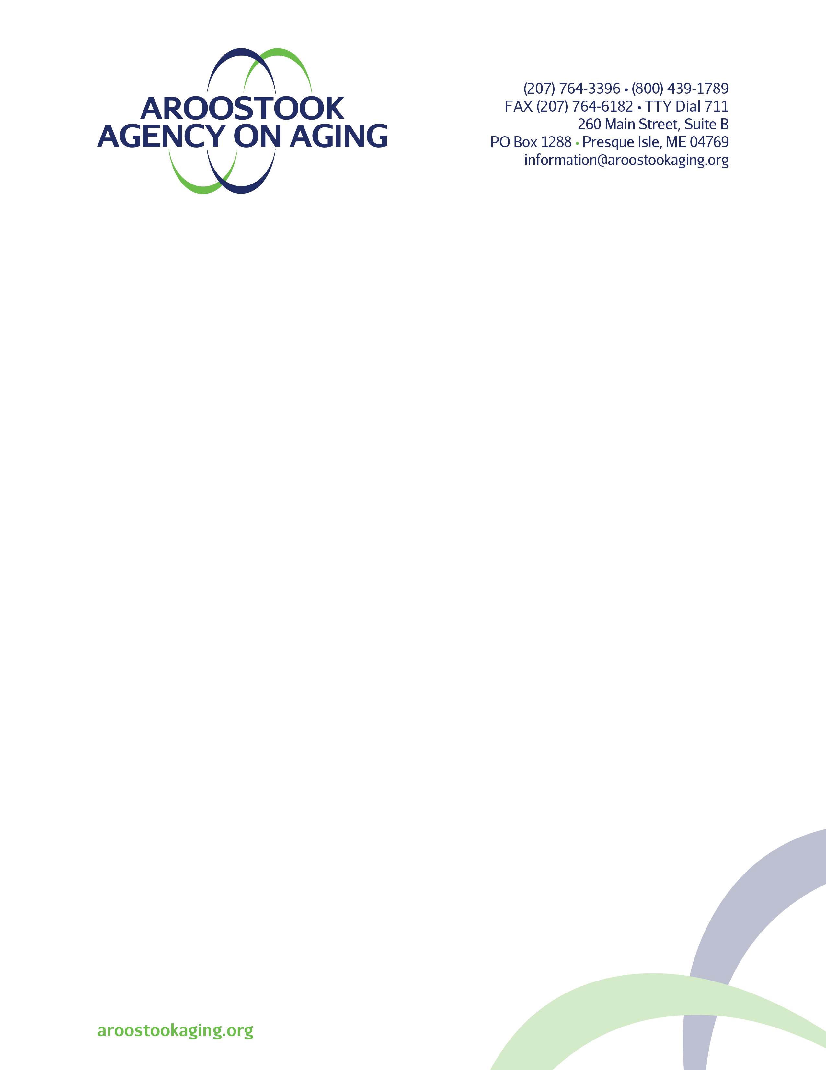­

Benefit Checklist for Maine – as of March 2022

**For Couple/Two- Person Household**

* Our monthly income is **less than $2,658** and one of us is at least age 60 or disabled. We have less than $5,000 in liquid assets. You may be eligible for the **Food Supplement Program (formerly food stamps).** Contact Maine Department of Health and Human Services – Fort Kent 1-800-432-7340; Caribou 1-800-432-7366; or Houlton 1-800-432-7338 for an application.
* **One of us or both are at least 60 or older and disabled. We are both homebound and have difficulty making meals**. You may be eligible for **Meals on Wheels**. To determine eligibility please call Aroostook Agency on Aging 1-800-439-1789 or 207 764-3396.
* Our monthly income is **less than or equal to $1,887** and we are both 60 years or older. You may be eligible for **Maine Commodity Supplemental Food Program**. Please call the Agency to learn more.
* Our monthly income is **less than $3,181.** You may be eligible for the **Home Energy Assistance Program (HEAP).**  *Out-of-pocket medical expenses can sometimes be subtracted to lower your monthly income*. Call Aroostook County Action Program at 1-800-585-3053 or 207-768-3053 to schedule an appointment.
* Our monthly income is **less than $2,832** and we are at least age 62 or disabled. We have **less than $75,000** in liquid assets. You may be eligible for the **Drugs for the Elderly and Disabled (DEL)** a prescription drug benefit. Your income may be higher if you are spending 40% of your income on prescriptions.
* Our monthly income is **less than $2,106** and we are under 65 and not on Medicare. There is no asset limit. You may be eligible for **MaineCare** (under new MaineCare adult expansion). Contact DHHS to learn more.
* Our monthly income is **less than $1,526** and we are both 65 or older and have a disabling condition per the criteria of the Social Security Administration.We have **less than $3,000** in liquid assets.  You may be eligible for **MaineCare for the Aged, Blind and Disabled.** *Cannot be eligible for Medicare Part A or B, or eligible in another coverage group.* Contact DHHS to learn more*.*
* Our monthly income is **less than $2,289** and we are enrolled in Medicare. We have **less than $75,000** in liquid assets. You may be eligible for the **Medicare Savings Program (Buy-In)**. Income can be higher if working or if only one spouse applies. **DHHS determines eligibility for these programs.** Please call the Agency to learn more.

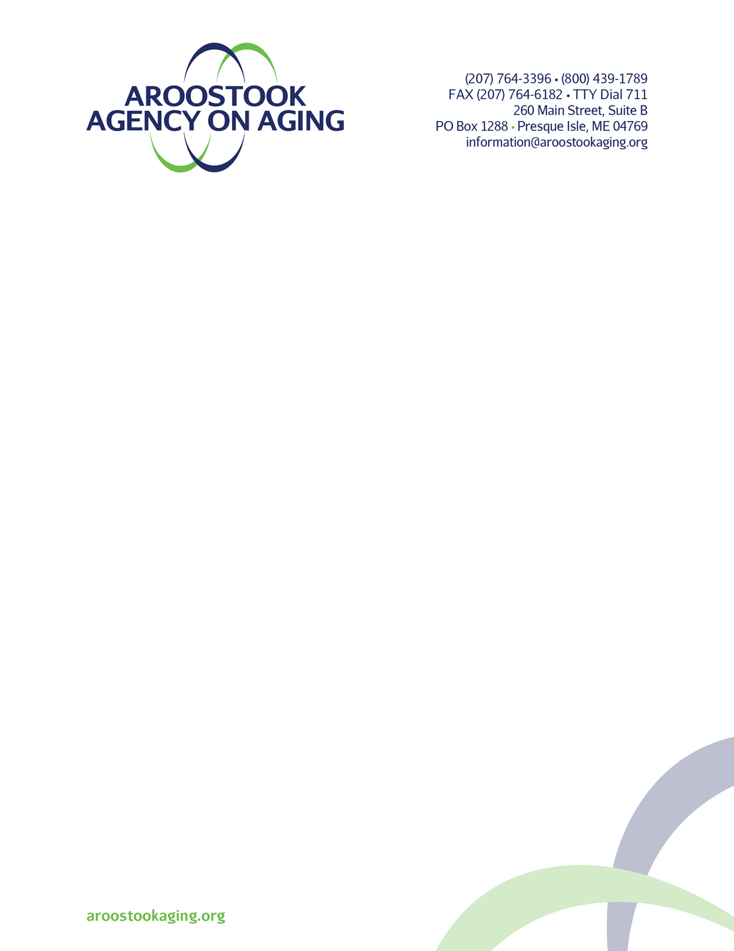

Benefit Checklist for Maine – as of March 2022

**For Couple/Two Person- Household**

* Our annual income **is less than or equal to $41,000** and we rent. You might be eligible to apply for the (**ERA Program)** **Emergency Rental Assistance Program.** If you are over income for this program and still need help, please know that there are some types of income that can be deducted from your overall household income. Call Aroostook County Action Program for more information.
* Our monthly income **is less than $5,341,** we spend more than 5% of our income on prescription drugs or 15% on medical expenses. You may be eligible for **Maine Rx Plus.** Cannot be combined with MaineCare or the Special Benefit Waiver. Unlike the DEL program, the RX Plus program does not consider one’s assets. Please call the Agency to learn more.
* We participate in an assistance program such as **SNAP, MaineCare, Federal Public Housing, SSI, WIC or Lifeline.** You might be eligible for **The Affordable Connectivity Program**. This is an FCC benefit program that helps ensure that one can afford the internet service they need for work, school, health care and more. **Please call Aroostook Agency on Aging at (800)-439-1789 or 207 764-3396, for any more information regarding any of the programs listed above.**
* ***The Low-Cost Drugs for the Elderly or Disabled and Maine Rx Plus Programs give a discount on prescription drugs only. They do not substitute for insurance coverage.***
* ***Liquid Assets include cash or other resources that can be converted to cash on demand.***